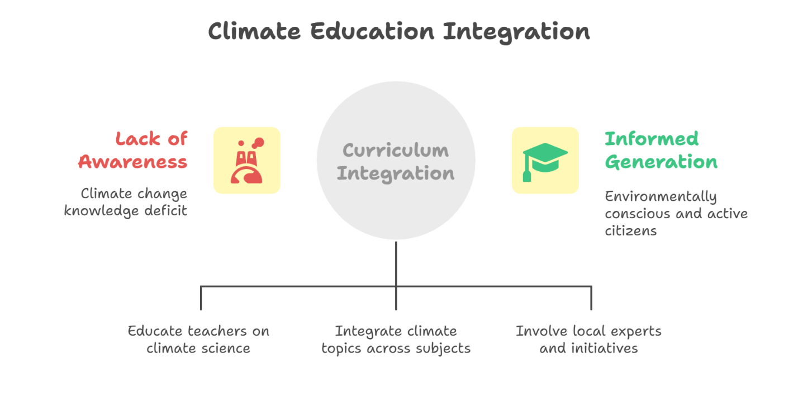

**Climate Education in Schools**

Climate education in schools is an essential component of preparing future generations to tackle the pressing environmental challenges of our time. This document explores the importance of integrating climate education into school curricula, the benefits it provides to students and communities, and effective strategies for implementation. By fostering a deeper understanding of climate change, its impacts, and potential solutions, we can empower students to become informed citizens and proactive stewards of the planet.

**Importance of Climate Education**

Climate education equips students with the knowledge and skills necessary to understand the complexities of climate change. It fosters critical thinking, encourages problem-solving, and promotes awareness of environmental issues. By learning about the science behind climate change, students can grasp the urgency of the situation and the need for collective action. Furthermore, climate education can inspire students to engage in sustainability practices and advocate for policies that protect the environment.

**Benefits of Climate Education**

1. **Empowerment**: Students gain confidence in their ability to effect change, both individually and collectively.
2. **Awareness**: Increased understanding of climate issues leads to more informed decision-making and lifestyle choices.
3. **Community Engagement**: Climate education encourages students to participate in local environmental initiatives, fostering a sense of community responsibility.
4. **Interdisciplinary Learning**: Climate education can be integrated across subjects, enhancing learning in science, social studies, and even art.

**Strategies for Implementation**

1. **Curriculum Development**: Schools should develop comprehensive climate education curricula that align with national and state standards. This can include lessons on the science of climate change, its social and economic impacts, and solutions for mitigation and adaptation.
2. **Professional Development**: Teachers need training and resources to effectively teach climate education. Workshops, seminars, and access to educational materials can enhance their confidence and competence in delivering this content.
3. **Hands-On Learning**: Incorporating experiential learning opportunities, such as field trips, community projects, and school gardens, can help students connect theoretical knowledge with real-world applications.
4. **Collaboration with Experts**: Partnering with local environmental organizations, scientists, and community leaders can enrich the educational experience and provide students with diverse perspectives on climate issues.
5. **Advocacy and Action**: Encouraging students to participate in advocacy efforts, such as climate marches or local policy discussions, can help them understand the importance of civic engagement in addressing climate change.

**Conclusion**

Integrating climate education into school curricula is crucial for fostering a generation of environmentally conscious citizens. By empowering students with knowledge and skills, we can inspire them to take action against climate change and contribute to a sustainable future. Schools play a pivotal role in this endeavor, and with the right strategies in place, we can ensure that climate education becomes a fundamental part of the learning experience